Market Monitor - Burkina Faso - 2026-04

Highlights
Food prices in Burkina Faso continued a downward trend in April, led by decreasing costs for major staples. Despite the overall decline, the price of beans saw a slight increase.
The cost of the food basket fell to 3600.36, representing a month-on-month decrease of 1.3% (↓) and a significant year-on-year drop of 28.5% (↓). Millet experienced the most significant monthly price drop (↓3.6%), followed by maize (↓2.3%). In contrast, the price of beans (niebe) rose by 1.5% (↑).
Key Drivers:
- The decline in the food basket cost was primarily driven by falling prices of key staples, notably millet (↓3.6%) and maize (↓2.3%).
- Substantial year-on-year price deflation persists across all monitored commodities, with the food basket price 28.5% lower than in the previous year.
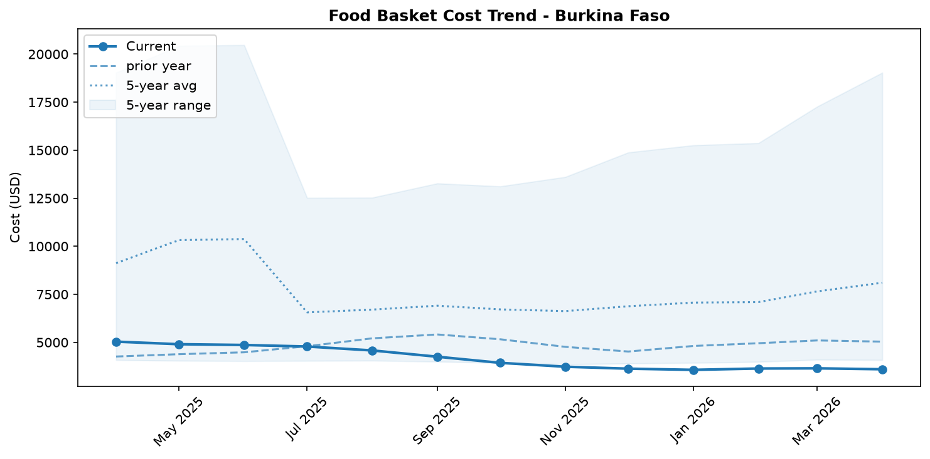
Food basket cost trend

Market Overview
In April 2026, the national average price of the food basket in Burkina Faso continued its downward trend, decreasing by 1.3% from the previous month. This trend is primarily driven by falling prices for key staples, particularly maize (-2.3%) and millet (-3.6%). On an annual basis, the market has experienced significant deflation, with the food basket price now 28.5% lower than in April 2025. This price behavior, however, contrasts sharply with the country's severe humanitarian context. Recent reports indicate that 1.7 million people are facing food insecurity and the number of internally displaced persons has reached 2 million, heightening household reliance on markets. The observed price decreases, despite strong demand-side pressures from market-reliant households and returning IDPs, are likely tempered by the impact of food assistance interventions. While current data shows price relief, the underlying drivers of food insecurity and the approaching lean season suggest this trend may soon face upward pressure. The recent price increase for beans could be an early signal of a market shift as households seek to secure food amidst depleted personal stocks.

Commodity Analysis
An analysis of individual commodities reveals a widespread, though varied, decrease in prices for staple cereals in April, while pulses moved in the opposite direction. Millet experienced the most significant month-on-month decline, falling by 3.6% to 286.48. The price of white maize also dropped notably by 2.3% to 173.39. In contrast, sorghum prices remained stable from the previous month, and local rice saw only a marginal decrease of 0.6%. Annually, all monitored cereals show substantial price drops compared to April 2025. Maize has seen the largest year-on-year deflation at -35.7%, while local rice recorded the most moderate decrease at -15.4%.
Contrary to the cereal trend, the price of niebe beans increased by 1.5% month-on-month, reaching 442.87. Despite this monthly rise, the price of beans remains 31.0% lower than the same period last year. This uptick in bean prices, while other staples are falling, may signal a shift in market dynamics. As households with depleted stocks prepare for the lean season, demand for relatively affordable protein sources like beans could be increasing, potentially indicating the beginning of broader price stabilization or increases in the coming months.
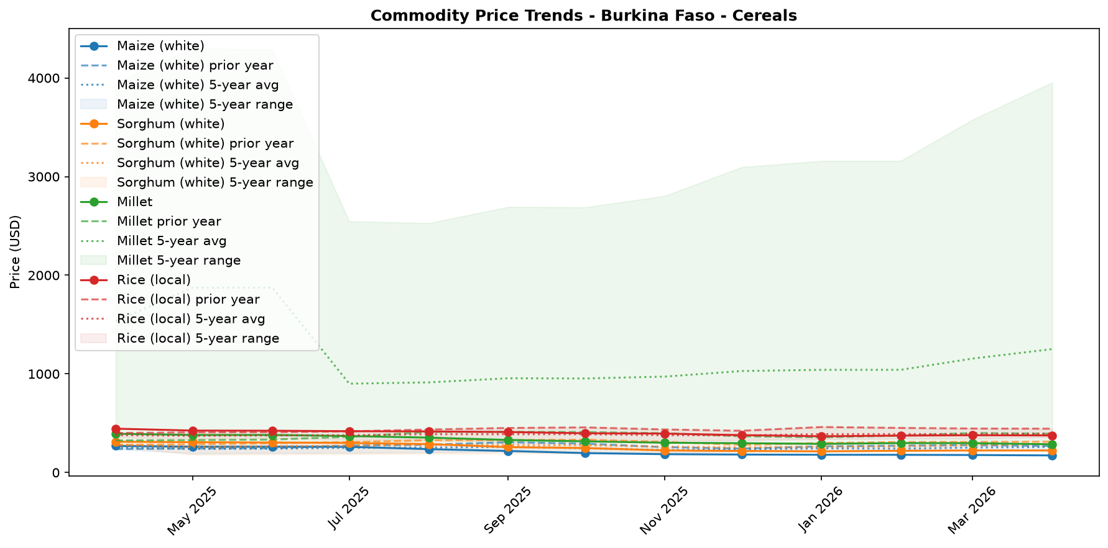
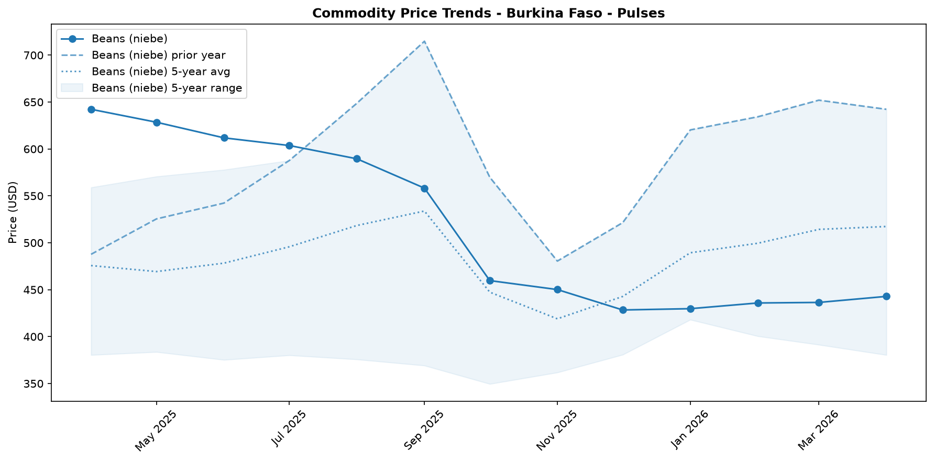

Regional Highlights
While national-level data indicates a 1.3% monthly decrease in the food basket price, this aggregate figure masks significant regional disparities and localized stress.
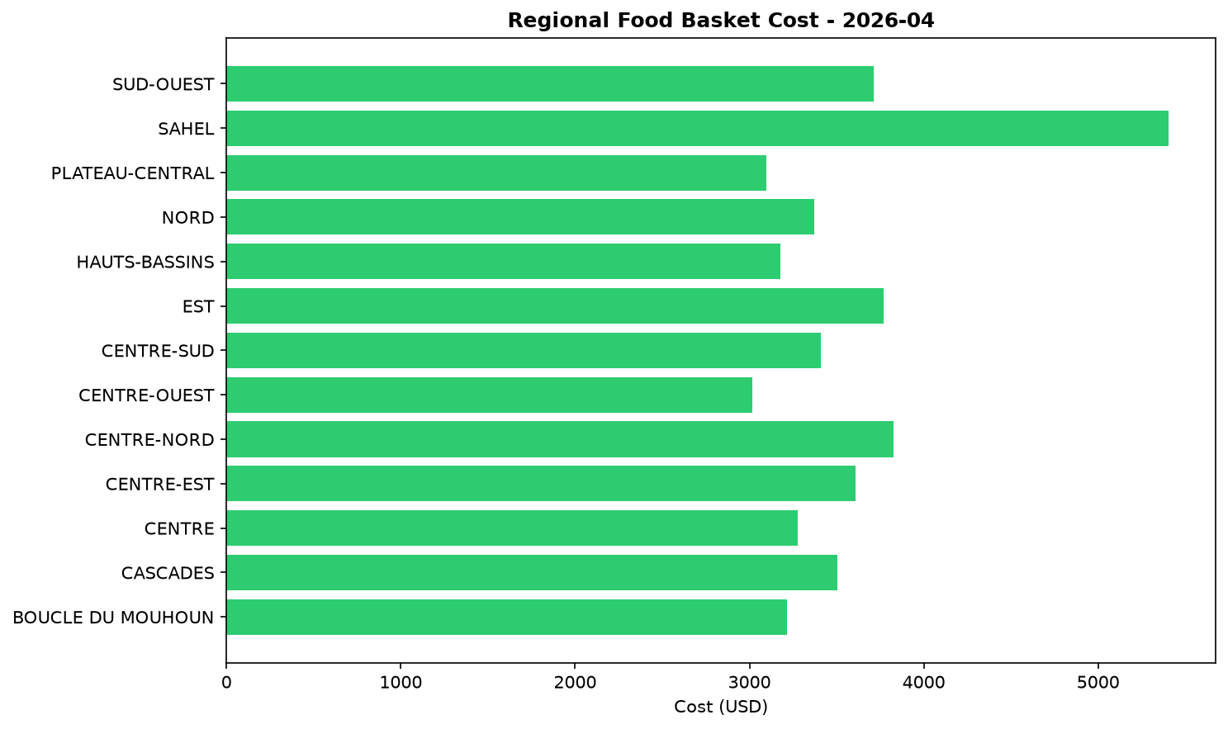
The situation in Karo-Peli Province exemplifies this contrast. Here, households are projected to face Crisis (IPC Phase 3) food security outcomes through May, driven by weak incomes and limited market access. Having exhausted their own food stocks from the previous harvest, the population is almost entirely reliant on markets and humanitarian aid for sustenance. The national price decreases are partially attributable to interventions in such hard-hit areas. For instance, significant food assistance was provided in Karo-Peli in March, covering a substantial portion of the population's needs. This aid likely supplemented market supply and prevented extreme food deficits, thereby tempering local price increases and contributing to the subdued national price average. This highlights a fragile stability where humanitarian action, rather than market fundamentals alone, is influencing price trends.

References
- [rw_4208918] ReliefWeb (2026-04-22) UNICEF Executive Director Catherine Russell’s remarks at the Humanitarian Dialogue – Humanitarian Priorities for Children in 2026
https://reliefweb.int/node/4208918
- [rw_4208090] ReliefWeb (2026-04-17) Rapport final indice de fonctionnalite des marches 2025
https://reliefweb.int/node/4208090
- [rw_4207091] ReliefWeb (2026-04-13) WFP Burkina Faso Country Brief, March 2026
https://reliefweb.int/node/4207091
- [rw_4207009] ReliefWeb (2026-04-13) Burkina Faso Key Message Update: Crisis (IPC Phase 3) persists in the north and east amid the lean season, March - September 2026
https://reliefweb.int/node/4207009
- [rw_4206645] ReliefWeb (2026-04-09) Integrating nutrient supplements and WASH into agriculture programs improves child micronutrient status in Burkina Faso
https://reliefweb.int/node/4206645
- [rw_4205328] ReliefWeb (2026-03-31) West and Central Africa: Latest Events at a glance (24 - 30 March 2026)
https://reliefweb.int/node/4205328
- [rw_4205099] ReliefWeb (2026-03-30) Bi-monthly Pastoral Surveillance bulletin in the Sahel N°35 / October-November 2025
https://reliefweb.int/node/4205099
- [rw_4205066] ReliefWeb (2026-03-30) Bi-monthly Pastoral Surveillance bulletin in the Sahel N°36 / December 2025 - January 2026
https://reliefweb.int/node/4205066
- [rw_4204694] ReliefWeb (2026-03-27) Situation in Central Sahel, Liptako Gourma and Coastal Countries - DTM Monthly Dashboard #65 (February 2026)
https://reliefweb.int/node/4204694
- [rw_4204486] ReliefWeb (2026-03-26) UNICEF West and Central Africa Region Humanitarian Situation Report No. 2 (End of Year), 31 December 2025
https://reliefweb.int/node/4204486
- [seerist_1028284] Seerist (2026-04-24) Government purchase of stake in mine underlines HIGH regulatory, contract risks for mining operators
- [seerist_1028238] Seerist (2026-04-21) Big Picture series: Hard currency decisions – Sahel juntas unlikely to abandon CFA franc
- [seerist_1028144] Seerist (2026-04-14) Big Picture series: Strait of Hormuz disruption to drive acute fiscal, supply chain challenges in Africa
- [seerist_1027861] Seerist (2026-03-20) Big Picture series: Beyond health – the implications of the America First Global Health Strategy

